Myers: Crickets and frogs and hawks oh, my!

Because Myers Parcels has all of it….water (seeps, pools, a stream and temporary pools), wooded slopes and *sunny, open grassland*, it can and does have the species pictured here. They are not likely to be found in your back yard or the neighborhood playground. It’s definitely a food chain that should not be broken.

The vacant lots you and I explored as kids are becoming few and far between in the new, ‘dense’ Seattle. And, as you know, kids are no longer allowed to just ‘go out and play’. But a supervised natural area could be a source of adventure for this generation of kids--a way for them to experience the sights, sounds and smells of the wild. The chirping of crickets, the night time chorus of frogs, the plaintive cry of a killdeer, the yips of a coyote--these are sounds of natural world.

Some families can’t afford to send their kids to camp, and they are too busy working two jobs to make ends meet to go for a Sunday drive. We can give them a taste of wild world by preserving Myers Parcels right here in the City limits.

After the photos below (gleaned from the internet) are the naturalist’s reports to which they were keyed. –Cass Turnbull

[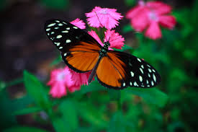](http://www.google.com/imgres?imgurl=http://upload.wikimedia.org/wikipedia/commons/0/0f/Painted_Lady_at_Butterfly_World.jpg&imgrefurl=http://commons.wikimedia.org/wiki/File:Painted_Lady_at_Butterfly_World.jpg&h=2592&w=3888&tbnid=PfdMpyXo_zmqgM:&zoom=1&docid=sr-e10UWQnIqDM&ei=iwI_VeT-NdCrogS69YHICg&tbm=isch&ved=0CFYQMygaMBo)[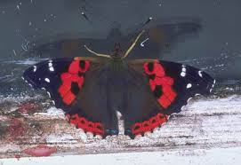](http://www.google.com/imgres?imgurl=http://www.butterfly-guide.co.uk/species/nymphalids/pics/iraup_home.jpg&imgrefurl=http://www.butterfly-guide.co.uk/species/nymphalids/t6.htm&h=309&w=450&tbnid=Y6hWxwMj8JvH1M:&zoom=1&docid=hVkFmN5bv6vgMM&ei=9AI_Vaf2BM62ogTN6oHADQ&tbm=isch&ved=0CB8QMygXMBc4ZA)[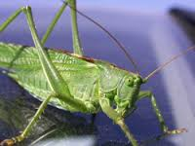](http://www.google.com/imgres?imgurl=http://www.iwnhas.org/images/Great_Green_Bush_Cricket_Redway_KM_02.jpg&imgrefurl=http://pinstake.com/green-cricket-insect/&h=188&w=250&tbnid=tZl-LMLLTxxHYM:&zoom=1&docid=pe24TFaQMlt4aM&itg=1&ei=dwo_VbTCCNjVoATus4CoAw&tbm=isch&ved=0CFkQMyhRMFE49AM)[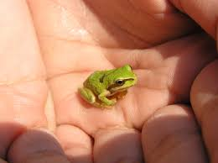](http://www.google.com/imgres?imgurl=http://www.wolfcollege.com/wp-content/uploads/2013/03/amphibian-pacific-tree-frog.jpg&imgrefurl=http://www.wolfcollege.com/more-signs-of-spring/&h=1712&w=2288&tbnid=XWol3Ri72wm6BM:&zoom=1&docid=1dddI26BgKVn0M&ei=5Ag_VZWXE4u3oQSK6YGoBw&tbm=isch&ved=0CEMQMygRMBE)[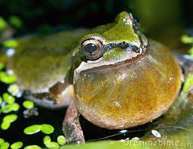](http://www.google.com/imgres?imgurl=http://thumbs.dreamstime.com/x/pacific-tree-frog-calling-11912172.jpg&imgrefurl=http://www.dreamstime.com/stock-image-pacific-tree-frog-trapped-image11912191&h=307&w=400&tbnid=R7ooQo4dn_x_GM:&zoom=1&docid=ucwPS23dddavjM&ei=5Ag_VZWXE4u3oQSK6YGoBw&tbm=isch&ved=0CHwQMyhAMEA) [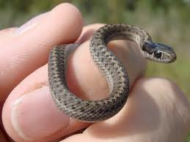](http://www.google.com/imgres?imgurl=http://www.albertawow.com/wildlife/garter%20snake/Garter%20Snake%20Baby%202.jpg&imgrefurl=https://www.pinterest.com/ellapennywick/garter-snakes/&h=563&w=751&tbnid=qqgggpvLE0wDrM:&zoom=1&docid=Afxb0ObzobgcZM&ei=LQw_VcaWFsLkoAS5tYG4Ag&tbm=isch&ved=0CBcQMygPMA84yAE) [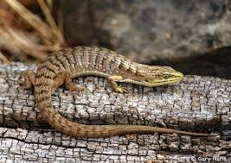](http://www.google.com/imgres?imgurl=http://www.californiaherps.com/noncal/northwest/nwlizards/images/emscincicaudaccor053.jpg&imgrefurl=http://www.knowledgedb.org/?imgid=48124-5&h=565&w=800&tbnid=97ZLLTz0JLWl2M:&zoom=1&docid=UehgnsfrM1bEyM&ei=qAw_Vbm-CoO7ogSZ4oDwDQ&tbm=isch&ved=0CDMQMygrMCs4ZA)[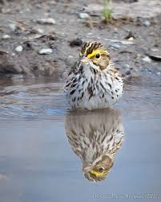](http://www.google.com/imgres?imgurl=http://songbirdphoto.com/wordpress/wp-content/uploads/2012/04/savannahSparrowBathing_20120408_IMG_8890.jpg&imgrefurl=http://songbirdphoto.com/wordpress/?p=1021&h=704&w=563&tbnid=TtkI3EQfk0SQXM:&zoom=1&docid=kfWBaLCBRMXl2M&ei=AQQ_VeOMH5LZoATdx4C4Dg&tbm=isch&ved=0CEgQMyhAMEA4yAE)[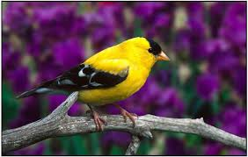](http://www.google.com/imgres?imgurl=http://www.birdwallpapers.com/wallpapers/charming-american-goldfinch-photo.jpg&imgrefurl=http://www.birdwallpapers.com/charming-american-goldfinch-photo.html&h=1024&w=1614&tbnid=91YioJ33b3UmdM:&zoom=1&docid=bbmlLzbCOk_FGM&ei=OwQ_VfrHN4mcoQTasICoBw&tbm=isch&ved=0CI0BEDMoUTBR)[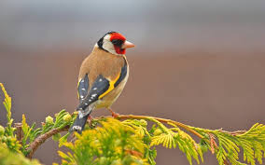](http://www.google.com/imgres?imgurl=http://voices.nationalgeographic.com/files/2012/04/Suranjan-Mukherjee-Goldfinch-Stafford-UK-950x593.jpg&imgrefurl=http://imgbuddy.com/european-goldfinch-breeding.asp&h=593&w=950&tbnid=04XtbVz0bDkPJM:&zoom=1&docid=PUBma3qp9qfWJM&ei=nAQ_Vay8IMa3ogS49YHYBg&tbm=isch&ved=0CGIQMyhaMFo4ZA)[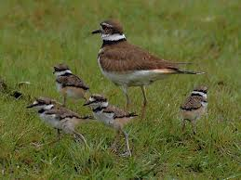](http://www.google.com/imgres?imgurl=https://s-media-cache-ak0.pinimg.com/originals/74/82/ed/7482ed32e04e76baefea45a57a7b9d11.jpg&imgrefurl=http://animal-kid.com/killdeer-bird-baby.html&h=900&w=1200&tbnid=3LOnZMVAU9jsTM:&zoom=1&docid=-46lEkCEKyo0MM&ei=2wQ_VZ7QO5emoQSdx4GgBA&tbm=isch&ved=0CGQQMygoMCg)[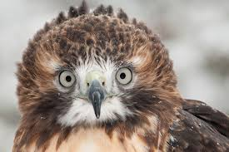](http://www.google.com/imgres?imgurl=http://media.salon.com/2013/12/red_tail_hawk.jpg&imgrefurl=http://www.salon.com/2013/12/28/raptor_porn_the_ridiculous_proliferation_of_the_red_tail_call/&h=500&w=750&tbnid=bFKDdyaTuDRwgM:&zoom=1&docid=m7YjCeSp6NS1wM&ei=twU_VaGLO8myogTA3IGoDg&tbm=isch&ved=0CB4QMygWMBY4yAE)

[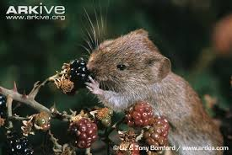](http://www.google.com/imgres?imgurl=http://cdn2.arkive.org/media/A6/A642E9BB-93FC-4FB8-B833-1D6F9A548128/Presentation.Large/Bank-vole-feeding-on-blackberries.jpg&imgrefurl=http://www.arkive.org/bank-vole/clethrionomys-glareolus/image-A15135.html&h=435&w=650&tbnid=OHUZKV7XJrlYMM:&zoom=1&docid=ENDmr4d85rSWtM&ei=TA8_VbfxBpLZoATdx4C4Dg&tbm=isch&ved=0CEwQMyhEMEQ4rAI) [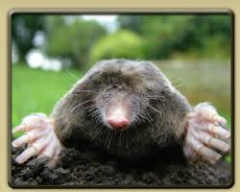](http://www.google.com/imgres?imgurl=http://www.cagesbyjim.net/images/mole-removal.jpg&imgrefurl=http://www.cagesbyjim.net/mole-removal.shtml&h=251&w=313&tbnid=NmCU5Puv3HaEXM:&zoom=1&docid=3zsh491fvJWeEM&ei=zQ4_VZ-4DcT3oATMrIDwCg&tbm=isch&ved=0CIMBEDMoXzBf) [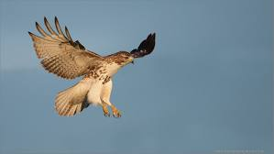](http://www.google.com/imgres?imgurl=http://focusingonwildlife.com/news/wp-content/uploads/2012/09/0G0G6340-2-Red-tailed-Hawk-1200-web-1.jpg&imgrefurl=http://pixshark.com/red-tailed-hawk-flying.htm&h=577&w=1024&tbnid=nQXD3ERw0W7KxM:&zoom=1&docid=0W5YI6Bij2inRM&ei=pQ4_VY-DHpO2ogTk6oDADw&tbm=isch&ved=0CAoQMygCMAI4ZA) [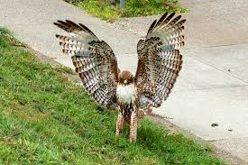](http://www.google.com/imgres?imgurl=http://10000birds.com/wp-content/uploads/2011/11/Red-tailed-Hawk-landing.jpg&imgrefurl=http://10000birds.com/patch-an-urban-red-tailed-hawk-1-of-4.htm&h=399&w=600&tbnid=PfD_1Um1pYAvEM:&zoom=1&docid=d1sosg9rS1Ma0M&ei=jwU_VZbMEcXroATJyYHQAQ&tbm=isch&ved=0CA8QMygHMAc4ZA) [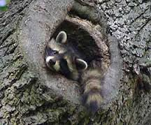](http://www.google.com/imgres?imgurl=http://www.hswlt.org/assets/images/270x224slideshow/raccoon/raccoon-5.jpg&imgrefurl=http://www.hswlt.org/wildlife/close-ups/raccoons.html&h=224&w=270&tbnid=4F24kcVYXsvCXM:&zoom=1&docid=vzjpUOFl6UFfTM&ei=-BA_VeHoL4e5ogSZsoGoDw&tbm=isch&ved=0CEEQMyg5MDk4ZA) [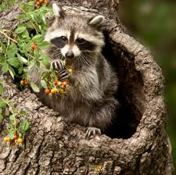](http://www.google.com/imgres?imgurl=http://www.varminter.com/wp-content/uploads/2012/11/Raccoon-1.jpg&imgrefurl=http://pixgood.com/raccoons-eating-fruit.html&h=346&w=347&tbnid=e4cbjunPmaURYM:&zoom=1&docid=hSxK6W0ka7fIVM&ei=HRE_VYnNDsS4ogS4-IC4Dw&tbm=isch&ved=0CCYQMygeMB44yAE) [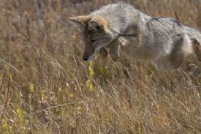](http://www.google.com/imgres?imgurl=http://media.jrn.com/images/coyote_whitney.jpg&imgrefurl=http://www.glendalenow.com/news/changing-coyote-behavior-is-key-to-coexistence-798nuag-190788731.html&h=2336&w=3504&tbnid=ouHXEO4Ad4LtcM:&zoom=1&docid=Q51rWd0HXbmpeM&ei=yA0_VZ3ZNpTpoATLp4CgDg&tbm=isch&ved=0CDEQMygpMCk4ZA) [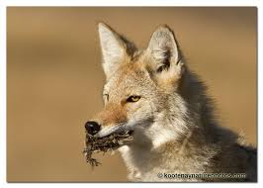](http://www.google.com/imgres?imgurl=http://www.kootenaynaturephotos.com/wp-content/uploads/2010/10/coyote_prey_2026_lr.jpg&imgrefurl=http://www.kootenaynaturephotos.com/category/saskatchewan/&h=600&w=840&tbnid=FIaNS9mMgCnBaM:&zoom=1&docid=I97B4WAl7lhtQM&ei=Kw4_VerKKIftoASlnYGIBQ&tbm=isch&ved=0CBUQMygNMA04yAE)

Myer's Parcels Report-from Stewart Wechsler, Nature guide and educator

The Myer's Parcels, as a 38 acre former sand and / or gravel mine within the Seattle city limits, is actually more special than it might seem without closer analysis. First of all there are few, if any other 38 acre or larger parcels within the city that are already owned by the city that are not designated “natural areas” that could be, and relatively few such natural land tracts already exist. Then, of any tracts of un-built, undeveloped land owned by the city, that may not have some kind of designation to protect their natural character, few, if any, are now being proposed for sale for commercial development.

While this land has been referred to as having “nothing there” by one city authority, this kind of perspective is all too often the result of a forestry school view of wild lands that seems to measure its value in board-feet of timber, rather than a degree to which the land does and could contribute to a richer local biodiversity for the larger area, with opportunities to engage the local community in learning about this, enjoying its different ecological offerings than a currently forested one, and possibilities for the community to be a part of directing the development of the natural community towards a native community type that might have existed before European contact. Some of the animal species already evident on an initial visit that prefer open or semi-open habitats to forested ones are both crickets and Pacific Chorus Frogs (Tree Frogs), whose songs are loved by many, native voles (mouse-like rodents), whose grass tunnels were evident, that feed both our Red-tailed hawks that frequent the general area and coyotes whose scat was evident on that initial visit.

This is also prime habitat for 2 local, native grasshopper species, that wouldn't be evident until later in the season than the survey was conducted. Countless other open to semi-open habitat adapted species, from bird to butterfly species, would surely be evident to careful observers at different times throughout the year. If the area were again surveyed between May and September on a sunny day, one might find garter snakes, adapted to this habitat type, and increasingly rare in the city of Seattle, and even possibly Northern Alligator Lizards, now even rarer within the city than the garter snakes.

What the sand / gravel mine has done is created one of the earliest types of successional communities, where the cover of the earlier plant community, the topsoil and even the earlier bank of seeds in the soil from earlier plant communities had been removed. This would be like a flood, a glacier or a land-slide might produce. This allows a new natural community to start from scratch, demonstrating one of the earliest natural successional community types.

There are 3 main habitat areas within the site, with smaller micro-habitats within these. First, there is the larger flat area west of Myer's Wy SW. This includes areas with different seasonal moisture levels, including a seep, where water flows out of the soil, but may dry out before the end of the dry season. It also includes areas where water forms small shallow pools, that we call “vernal pools” that will dry out before the end of the dry season, that certain plants and animals are specifically adapted to, but are rarely understood for their ecological value. One of these native plant species, Montia fontana – Annual Water Miners-lettuce, uncommon in Seattle, and adapted to areas wetter in winter, that become drier than most before the end of the dry season, was already evident, Second, there is the east facing steep slope, with a narrow, flat terrace about 2/3 the way up, on the west side of the tract. Then, third, on the south end of the tract is the now wooded, north facing slope with a now wooded flat area to the north of this. This area is largely covered by younger Red Alders, our locally dominant early successional tree.

These early successional micro-habitats also have special potential for engaging the community in the selective seeding of small patches of local, wild gene stock of native species not currently at the site, and letting them spread where they will with some assistance. The assistance would be having those community groups who are interested weeding non-natives from a small radius around the patches of natives that were seeded or planted.

While the early successional species now at the site are dominated by non-natives, this weeding around the seeded or planted native “mother plants” could allow these early successional natives a chance to spread, replacing the existing non-natives.

While the Seattle Parks Department may have indicated that there is less of a need for a park at this site because they already have Westcrest Park in the vicinity, from an ecological perspective, having two natural areas close together gives greater potential for greater ecological diversity. This greater ecological diversity would give a greater enrichment to the lives of the residents of the area. Larger connected, or close together patches of natural area will support a greater diversity of species, just as a larger human community will support a greater diversity of professions. There will also be some species that are adapted to using both the sunny, early successional habitat Myer's Tract and the mostly forested Westcrest Park that benefit from having the two natural areas close to each other. Such species might include a hawk that would nest in the forest, but hunt for voles, currently common in the grass in the flat part of the open, sunny Myer's Tract.

This is a brief summary of why this tract of wild land is more valuable, both to the ecological community and to our human community, than it might appear to some.

The following is a naturalist’s report on Myers parcels that cites the area being characterized as being not ecologically significant. The boldface is from me, Cass.  I thought you might find it interesting

Cass

206-783-9093

**From:** Stewart Wechsler [<mailto:ecostewart@gmail.com>]   
**Sent:** Monday, April 27, 2015 6:47 PM  
**To:** Dean Peloquin  
**Cc:** Cass Turnbull  
**Subject:** Re: Possible peak migration visit to Myer's Tracts today

First Dean, while I'm thinking of it, I just looked up that Mustard Family plant I had in my hand and it is "Field Pepperweed" - Lepidium campestre, a non-native I hadn't found in the earlier survey work.  And Cass, while Dean will be sending me a list of things he recorded for us, I thought I'd give a quick report, confirming much of what I had hoped we'd find in a visit today.

The native butterflies that have been migrating in were indeed flying at the Myer's Parcels. **We probably saw about 4 or 5 native butterflies of the genus Vanessa**, all but one flying too quick to determine which species, the one of which slowed down enough to confirm what species it was, was a Red Admiral - Vanessa atalanta, others would have been either **Red Admirals or Painted Ladies**, Vanessa cardui, a species that is just arriving to Washington State in the biggest numbers in years (they have big numbers when the desert SW has extra water and produces a bumper crop of butterfly food plants, and a bumper crop of Painted Lady butterflies with it.)

Among birds, while we didn't find the **Yellowthroats (warblers**) that I hoped we might, we found **large numbers of Goldfinches**, which I had hoped and expected, and which love that semi-open habitat with intermittent trees, shrubs or taller herbaceous plants to perch on and sing from.  We also saw and heard a **Killdeer, another one that loves the open spaces, especially those with some extra moisture, as we are still finding in the wetter spots there.  One more bird I had hoped to find there, that I had just suggested above that we might see, and that we indeed found just as we were headed out of the SW corner, was a Savannah Sparrow, a species that needs more open, relatively wild, grassy areas, which we don't see in large numbers in Seattle, because of the limited larger tracts of more open, relatively wild grassy habitat.  Also in my earlier report I mentioned that Red-tailed Hawks would love to hunt there, but would prefer an older wooded area to nest in.  Sure enough we saw a Red-tailed Hawk that was hunting over the site!**

And Cass, I had mentioned that some of what we would observe would be by smell and Dean could tell you that we indeed smell a couple of the plants whose smell is distinctive, one of which, the Common Tansy, Tanecetum vulgare, would release its odor as we walked through it disturbing the leaves.  Another one that we only found a plant or two of, but that I had missed on the earlier survey, and had a lovely smell, was Coastal Wormwood - Artemisea suksdorfii, a less common native, that would also provide food for the Painted Lady butterfly caterpillars if one of the mothers stops to lay some eggs.

-Stewart

On Mon, Apr 27, 2015 at 9:43 AM, Stewart Wechsler <[ecostewart@gmail.com](mailto:ecostewart@gmail.com)> wrote:

Dean, (and Cass)

It is now peak bird migration season, not to mention migration / arrival time for 2 migrant butterfly species, and flight time for a couple of non-migratory butterflies that had spent the winter and early spring in their pupae transforming into the winged adult butterfly stage and have started to fly!  At the Myer's tract, among new arrival birds, I hope I might now see Yellowthroats - a Warbler, not very common in Seattle, that likes that kind of semi-open habitat with intermittent shrub / sapling tree patches, and I'd be looking for Savannah Sparrows, that like the open habitat, but don't need as many shrubs as the Yellowthroats do.  The Painted Lady butterflies have started to arrive from the south in the largest numbers in many years, and we would quite likely see one on a warm, sunny, relatively calm day like today is forecast to be.  Other plants and animals, not readily evident earlier, are sure to make themselves known by their colored blooms or wings, their songs or their smells!

I will be heading from my coffee shop, where I am now, to my apartment shortly (where I don't have internet access), and likely headed out again not a lot later.  If you are lucky enough to get this e-mail before I have come and gone from my apartment, or before I possibly leave a second time, but before I possibly head to the Myers Tracts (maybe sometime between 11am and 4pm), and you are lucky enough to be free today you could call me and then join me.  As you may remember I am still a luddite without a cell phone, so I'll be relatively limited as to when you can reach me. but you can always leave a message.

[206 932-7225](tel:206%20932-7225) (land)